

**European Defence Fund**

***From defence research through development to implementation***

***European Commission***

*Directorate-General for Defence Industry and Space*

*European Defence Fund – Capability development*

**ENTR F**



July 2014

September 2016

November 2016

June 2017

December 2017

June 2018

July 2018

April 2019

**Political context**



**Political guidelines of President Juncker:** strengthening European citizens'security is a priority. Europe must become a security provider.

**State of the Union speech in 2016**: announcement of the creation of aEuropean Defence Fund and the need to go towards a European Defence Union.

**European Defence Action Plan** adopted, the Commission announced theinitial parameter of a possible European Defence Fund, and started the Preparatory Action on Defence Research with a budget of €90m for 3 years.

Commission launched **the European Defence Fund**: A two-step approach

Two initial programmes in the current budget (the Preparatory Action and a proposal for the European Defence Industrial Development Programme)

Scaled up funding for the new MFF: European Defence Fund

**Permanent Structure Cooperation** (PESCO) with 25 Member States, and 34concrete operational cooperation projects

Commission adopted its proposal for a European Defence Fund regulation

Council and European Parliament adopted the EDIDP regulation

Council (27 Feb) and European Parliament (18 Apr) found EDF partial agreement





**Rationale for the European Defence**

**Fund**



|  |  |  |
| --- | --- | --- |
| ECONOMIC | Reduction of inefficiencies of the current market, |  |
| synergies and economies of scale |  |
|  |  |



STRATEGIC Strategic autonomy of the Union



|  |  |  |
| --- | --- | --- |
| POLITICAL | Protection of the basic interest of the Union and its |  |
| Member States |  |
|  |  |





**COMPLETE CAPABILITY**

**DEVELOPMENT CYCLE**

**Research Window** **Capability Window**

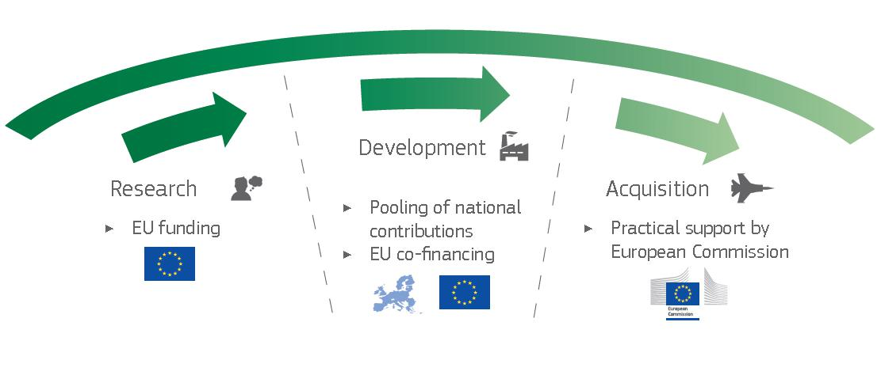

* **European Defence Research**

|  |  |  |  |
| --- | --- | --- | --- |
| **Programme** | **European Defence** |  |  |
|  | **Financial Toolbox** |  |
|  | **Industrial Development** |  |
|  | **Programme** |  |  |





**COMPLETE CAPABILITY**

**DEVELOPMENT CYCLE**

|  |  |  |
| --- | --- | --- |
| **Research Window** | **Capability** | **Window** |

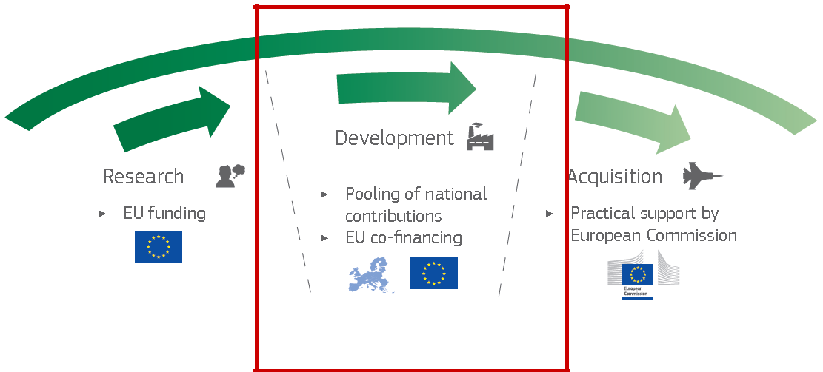

* **European Defence Research**

|  |  |  |  |
| --- | --- | --- | --- |
| **Programme** | **European Defence** |  |  |
|  | **Financial Toolbox** |  |
|  | **Industrial Development** |  |
|  | **Programme** |  |  |





**EUROPEAN DEFENCE INDUSTRIAL**

**DEVELOPMENT PROGRAMME**

* Duration: **2 years** **→** **2019-2020**
* Budget: **EUR 500 million** for the period 2019-2020
* Objectives:
  + foster the competitiveness, efficiency and innovation capacity of the defence industry throughout the Union, thus contributing to the Union's strategic autonomy;
  + support and leverage the cooperation including across borders between undertakings including SMEs and mid-caps;
  + foster better exploitation of the results of defence research and contribute to development after the research phase.





**Cross-border SMEs participation**

* EDIDP not only for large Member States and large companies

– it provides **opportunities for all EU's defence industry** regardless of size and location within the EU.

* Award criteria and bonus system for project with substantial cross-border SME participation
* 10% of the overall budget shall benefit the **cross-border** **participation** of SMEs
* Specific project category solely focused on consortia of SMEs





**EUROPEAN DEFENCE INDUSTRIAL**

**DEVELOPMENT PROGRAMME**

* **Work programme published on 19th March 2019**
* Prepared by the Commission **in close cooperation with Member**

**States**

* Describes categories of defence capabilities for competitive calls for proposals in 2019 and/or 2020 (21 calls in total)
* **Work programme covers:**

o all domains: land, sea, air, cyber and space o 17 categories of capabilities

o >50 capabilities (topics)

* Provides indicative budget and targeted activities for each category of projects





**EUROPEAN DEFENCE INDUSTRIAL**

**DEVELOPMENT PROGRAMME**

* **2020 Call – Categories:**
* *Chemical Biological Radiological Nuclear (CBRN) detection capabilities and medical*

*countermeasures*

* *Underwater control contributing to resilience at sea*
* *Counter-Unmanned Air Systems (UASs) capabilities*
* *Cyber situational awareness and defence capabilities, defence networks and technologies for secure communication and information sharing*
* *Space Situational Awareness (SSA) and early warning capabilities*
* *Maritime surveillance capabilities*
* *Upgrade of current and development of next generation ground-based precision strike capabilities*
* *Ground combat capabilities*
* *Air combat capabilities*
* *Simulation and virtualisation tools and equipment for training, exercises, systems design, development and integration, testing and validation*
* *Defence technologies supported by artificial intelligence*
* *Category for SMEs – Innovative and future-oriented defence solutions*





**Eligible actions**

1. studies, such as feasibility studies, and other accompanying measures
2. the design the system prototyping;
3. the testing;
4. the qualification;
5. the certification;
6. the development of technologies or assets increasing efficiency across the life cycle of defence products and technologies.





**Funded Activities and requirements**

* EDIDP activities cover the development of new and the upgrade of existing defence products and technologies
* Costs of the action that are not covered by Union support are to be covered by other means of financing (such as Member States co-financing)
* Design must be based on common requirements jointly agreed by at least two Member States.
* System prototyping, testing, qualification, certification, development of life-cycle technologies:

1. must be based on common technical specifications jointly agreed by the Member States that are to co-finance or that intend to jointly procure the final product or to jointly use the technology;
   1. at least two Member States need to show the intention to procure the final product or to use the technology in a coordinated way, including through joint procurement where applicable.

* The results of actions which receive funding shall not be subject to non-EU control or restrictions





**Participation rules**

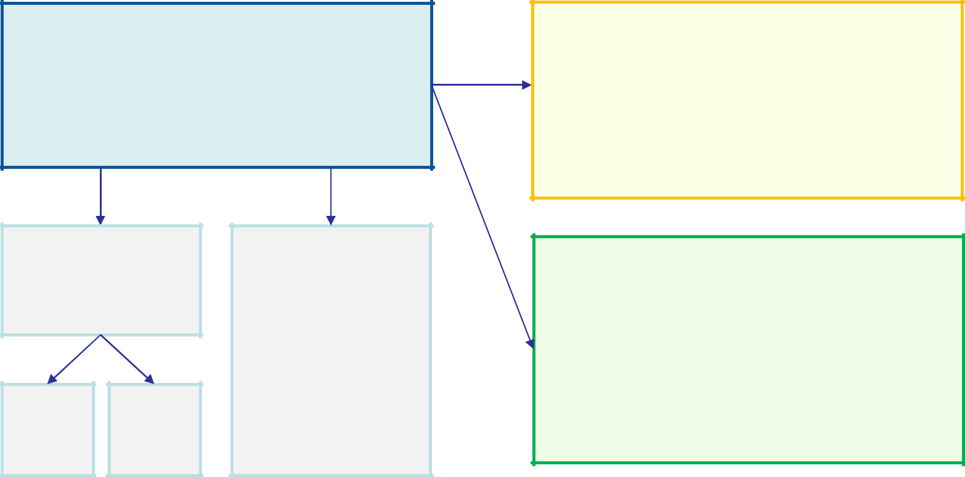

**Consortium**

* 3 undertakings from 3 MS
* Management structures established in the Union & Infrastructure, facilities, assets and resources located in Union
* Derogations possible Art. 7 (4/5)

**Associated Partners**

- International Partners -> have to fulfil

conditions of Art. 7(6)

* Non-SMEs in SME-Category -> have to fulfil same eligibility criteria as beneficiaries
* **No EU-Funding !**

**Subcontractors**

Art. 7(8)

|  |  |  |
| --- | --- | --- |
| **SCs** | **SCs** |  |
| Art. |  |
| n/a |  |
| 7(8) |  |
|  |  |

**Suppliers**

* Procurement of ordinary services, goods or equipment
* No outsourcing of entire parts of the action

**Linked third parties**

* Third parties with a legal or capital link with a beneficiary that can implement a part of the action in their own name and claim their own costs -> have to fulfil the same eligibility criteria as beneficiaries
* **EU funding**



DEROGATIONS

* **Non-EU controlled** undertakings areeligible, if **guarantees** approved by their Member State assuring that their participation does not contravene the **security and** **defence interests** of the EU and itsMember States or the **objectives** of EDIDP/EDF. They shall in particular substantiate that,

1. No risk in the ability to perform the action
2. Sensitive information is protected
   1. IPR should remain in the EU, Export only with approval by the Member State

* Possibility to **cooperate with** **entities located outside** the Unionunder strict conditions but no funding for the related costs (Article 7(6) EDIDP Regulation)

DEROGATION FOR

COOPERATION WITH

NON-EU COPMANIES

DEROGATION FOR NON-EU

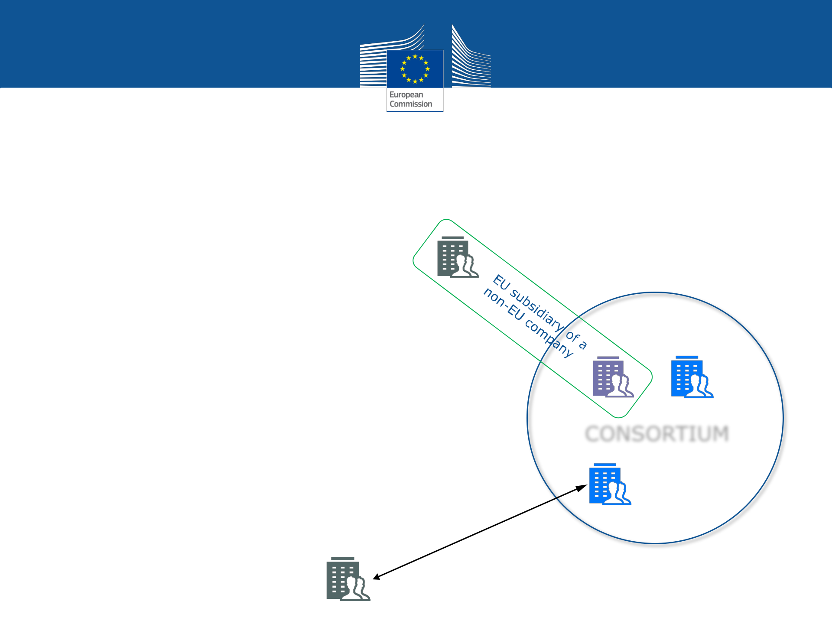

CONTROLLED EU COMPANY

CONSORTIUM



**Funding rates**

1. studies, such as feasibility studies, and other accompanying measures **–** **90% of total eligible costs**
2. the design **–** **65% of total eligible costs**
3. the system prototyping **–** **20% of total eligible costs**
4. the testing **–** **65% of total eligible costs**
5. the qualification - **65% of total eligible costs**
6. the certification - **65% of total eligible costs**
7. the development of technologies or assets increasing efficiency across the life cycle of defence products and technologies - **65% of total eligible costs**





**Bonus system**

* +10% in case the action is developed in the context of

PESCO

* Where at least 10% of the total eligible cost of the action is allocated to SMEs established in the Union:

1. % equal to the percentage of the total eligible cost of an action allocated to SMEs established in Member States in which the undertakings in the consortium that are not SMEs are established (maximum 5%)
   1. Twice the % of the total eligible cost of an action allocated to SMEs established in Member States other than those referred to in the previous point

* +10% where at least 15% of the total eligible cost of the action is allocated to mid-caps established in the Union
* **Maximum bonus cannot exceed 35%**





**Award criteria**

* contribution to excellence;
* contribution to innovation;
* contribution to the competitiveness and growth;
* contribution to the industrial autonomy of the European defence industry and to the security and defence interests of the Union;
* participation of SMEs / cross-border SMEs;
* contribution to the further integration of the European defence industry;





**EDIDP next steps**

* **1st trimester 2020**:
  + Publishing of the 2020 call for proposals
  + Selection of first projects for 2019 calls
  + Negotiation and signature of Grant Agreements with the beneficiaries



***EDIDP***

**All calls available on the Funding and Tender opportunities Portal**

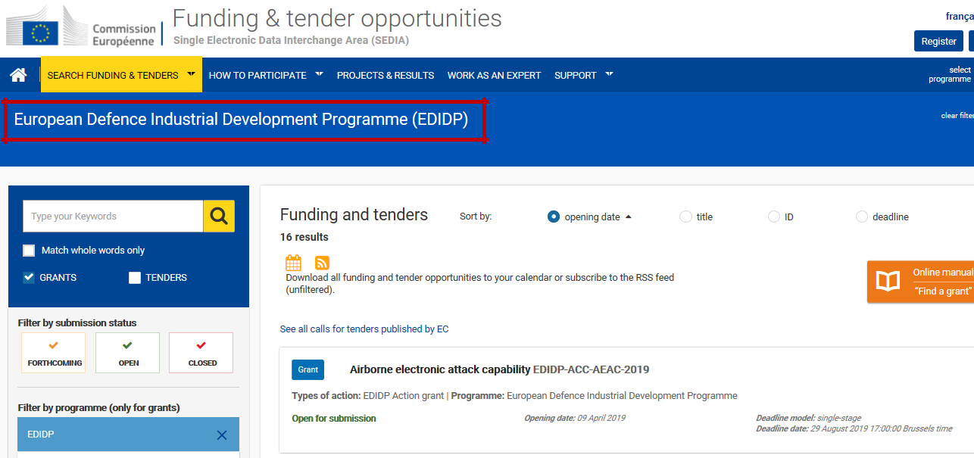

18





**The European Defence Fund**

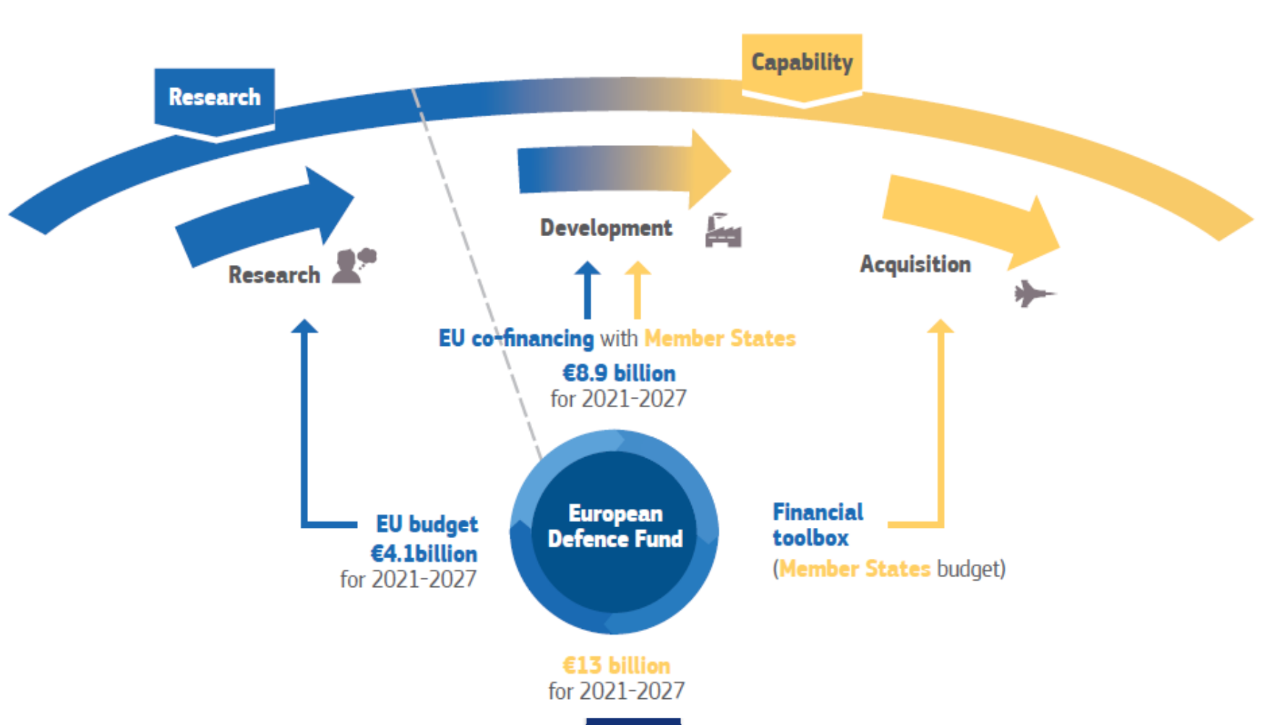



**EUR 13 billion* for 2021 – 2027**

*(*estimate-not decided***)**

**2021-2027:** **EU financing rate:**

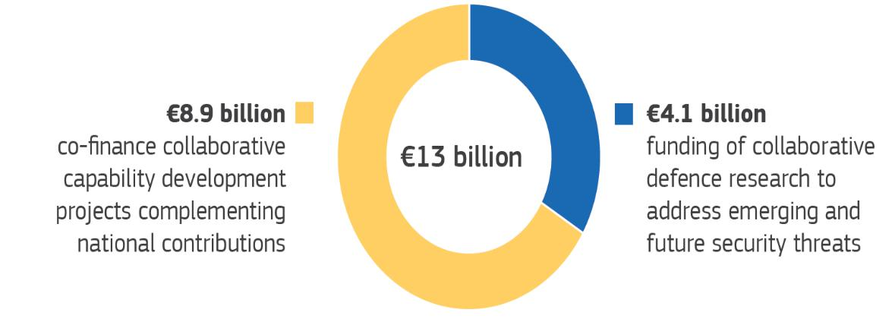

▪ **Research:** up to **100%**

▪ **Prototypes:** up to **20%**

▪ **Post-prototype:** up to **80%**

▪ **25% of the total direct** **eligible costs** as flat rate forindirect costs or determined on the basis of actual indirect costs

***Additional incentives:***

* Cross-border participation of **SMEs/midcaps** – EU funding rate increasing with the level of cross-border participation of SMEs/midcaps in the projects (higher for SMEs)
* PESCO (if eligible): +10% co-financing bonus



***Call for***

***Experts***

**Call for Experts**

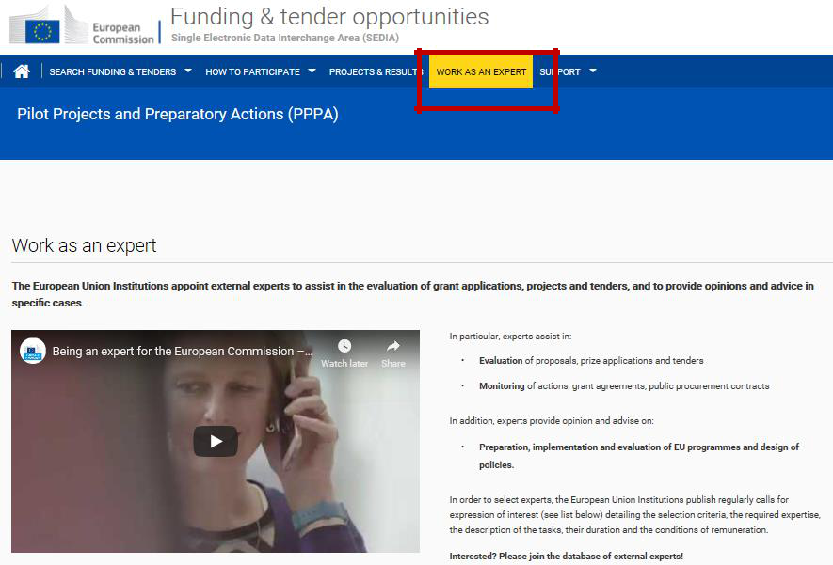

* **Experts need to be validated by national authorities**
* **Experts need appropriate personal security clearance**

[**https://www.eda.europa.eu/docs/default-source/procurement/2017-call-for-experts.pdf**](https://www.eda.europa.eu/docs/default-source/procurement/2017-call-for-experts.pdf)[**https://ec.europa.eu/growth/content/call-expression-interest-establish-list-experts-assist-**](https://ec.europa.eu/growth/content/call-expression-interest-establish-list-experts-assist-european-commission-tasks-connection_en) 21[**european-commission-tasks-connection_en**](https://ec.europa.eu/growth/content/call-expression-interest-establish-list-experts-assist-european-commission-tasks-connection_en)





* ***Thank you!***